

**Semester I 2023/2024**

Group Member : Wong Ya Jing A24CS0211

: Chia Thung Thung A24CS0060

: Abralyn Hoo Weng Yan A24CS0218

: Edwin Oo Ming Hao A24CS0245

: Yeoh Keng Wei A24CS0316

Subject : Technology and Information System (SECP1513)

Section : 05

Task : Design Thinking

Theme : Big Data And Artificial Intelligent New Innovation

Project Name : Smart Retractable Canopy

|  |  |  |
| --- | --- | --- |
| No. | Table of Content | Page |
| **1.** | **Introduction** | **3** |
| 1.1 | Problem Statement | 3 |
| 1.2 | Objective | 3 |
| **2.** | **Detail Step and Description of Design Thinking** | **4** |
| 2.1 | Defining problem | 4 |
| 2.1.1 | Idea Brainstorm | 4 |
| 2.1.2 | Design Draft | 5 |
| 2.1.3 | Interview | 9 |
| 2.1.4 | Preparation of Material | 10 |
| 2.2 | Working on product prototype | 11 |
| **3.** | **Design Thinking Evidence** | **12** |
| 3.1 | Empathy | 12 |
| 3.2 | Define | 12 |
| 3.3 | Ideate | 14 |
| 3.4 | Prototype | 15 |
| 3.5 | Test | 16 |
| **4.** | **Summary** | **17** |
| 4.1 | Reflection | 18 |
| 4.2 | Role for Each Team Member | 19 |
|  |  |  |
|  |  |  |

1. **Introduction**

This report outlines the process of our final product which is the “Smart Retractable Canopy”. We came up with this project because we find out that a canopy is usually in its permanent position and not flexible. Some landed-house doesn’t include an extended canopy. If the weather is raining, people might get wet when they get out of the car. If the weather is hot, the housing area will also be hot.Our project innovates a canopy to be more flexible and controllable anywhere, anytime with the aid of Internet of Things(IoT) and Artificial Intelligence(AI). Our target user is a landed-house owner with a car poach.

**1.1. Problem Statement**

* Due to different weather conditions, people can’t get out of their car comfortably.
* Normal canopy needs to be controlled by a person manually, so is unfriendly to the owner who is living alone.

**1.2 Objective**

* Helps people live and work smarter
* Leads to a more automatically world

1. **Detail Step and Description of Design Thinking**

This chapter will outline the progress throughout our design thinking project. This chapter will contain detailed steps and descriptions throughout the design thinking project along with evidence.

**2.1 Defining Problem**

To define a problem, our team did an interview and a survey to investigate the problem. Through an interview with our friends, we are able to locate the problem of the origin product of canopy. We also did a survey that consists of different ages to have a more holistic view of the recent problem.

**2.1.1 Idea Brainstorm**

After our first meeting, we came out with an innovative product on the canopy which is a Smart Retractable Canopy. It consists of a Humidity sensor, Light sensor, temperature sensor, 3 sensors that helps to indicate the environment situation. With the help of WiFi, it can access the weather forecast. GPS tracker in phone helps to locate the user’s location.

1. 1st situation- the user is working outside, and suddenly it is raining when he/she is heading home. The AI depends on the user’s location and opens the canopy while the user is reaching home.
2. 2nd situation- the light sensor and temperature sensor indicates hot weather. Open canopy to provide shade.
3. 3rd situation- normal situation, weather normal, canopy is close.
4. 4th situation- senses strong wind will close the canopy to avoid the canopy being destroyed.
5. 5th situation- can be controlled manually. Eg. The owner want to have party at home or wash their own car.

[**Thinking Design Project Draft 31/10**](https://docs.google.com/document/d/1V4K3qwBX9bpi3sXuK9wp9qqGzw9ONTcOwclYgeCuPRU/edit?usp=sharing)

So, the final idea we decided is a smart retractable canopy and we came up with different designs.

**2.1.2 Design Draft**

**FIRST DRAFT**

**SECOND DRAFT** 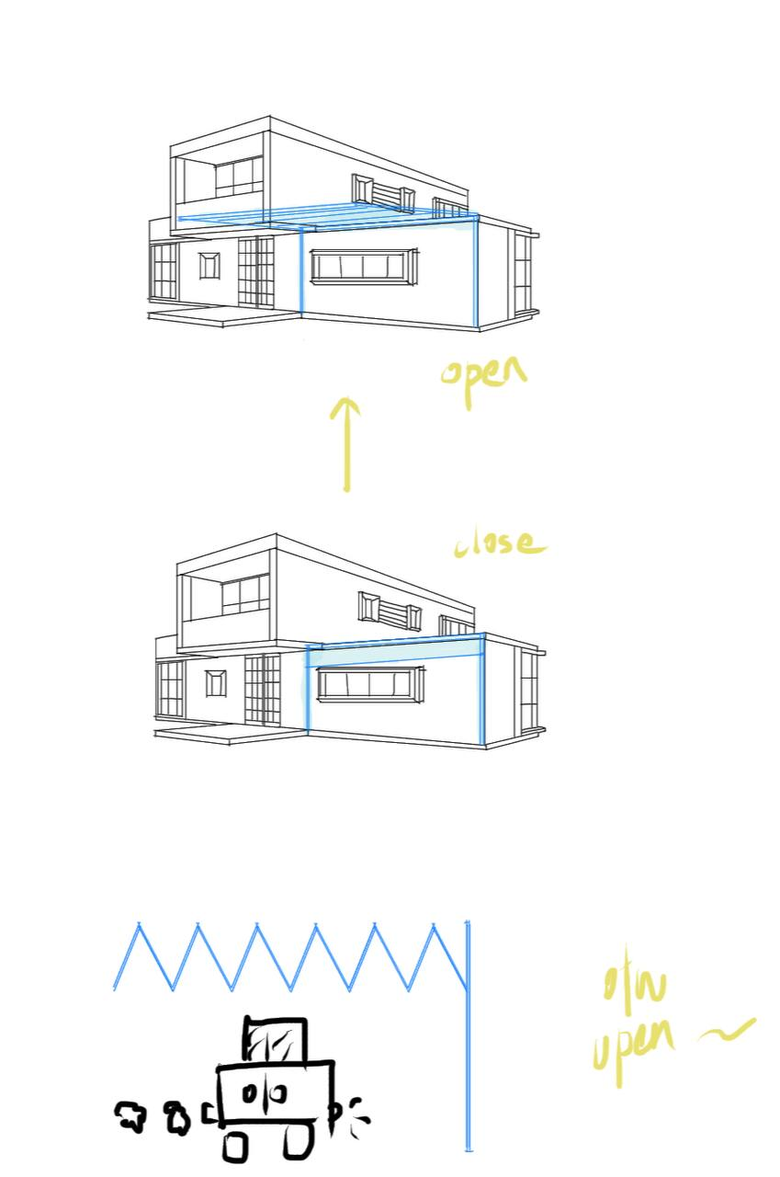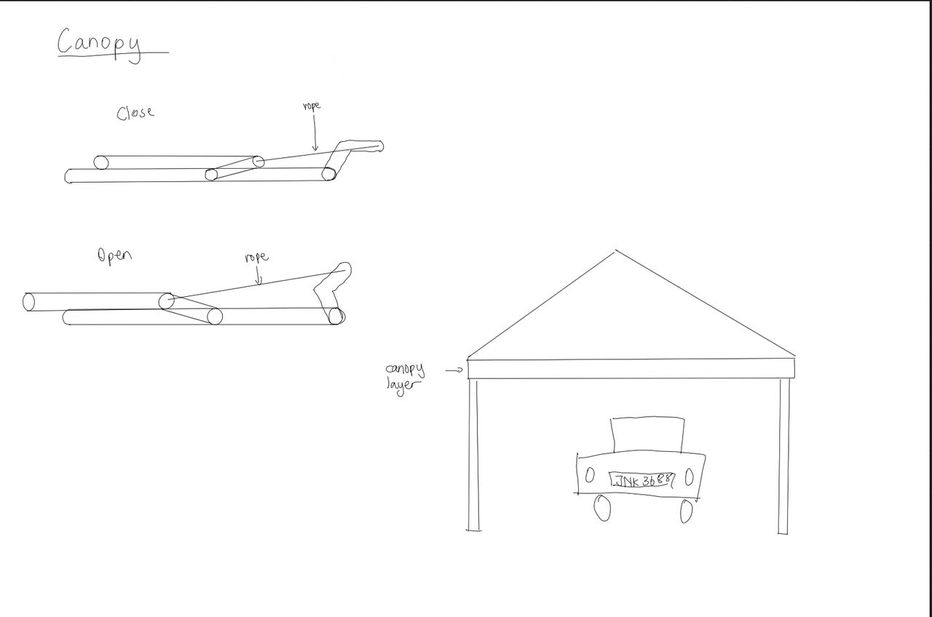

**THIRD DRAFT**

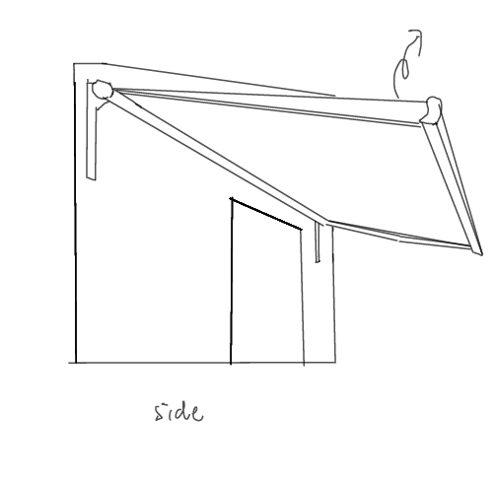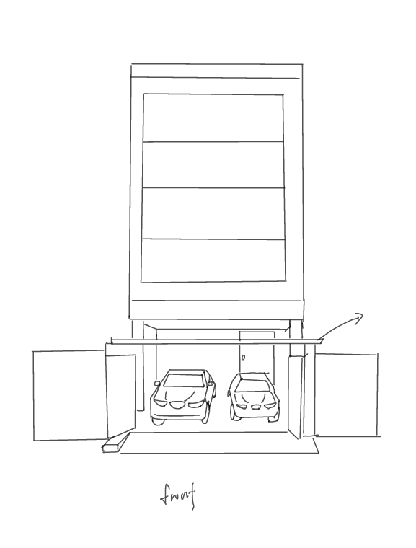

**FOURTH DRAFT**

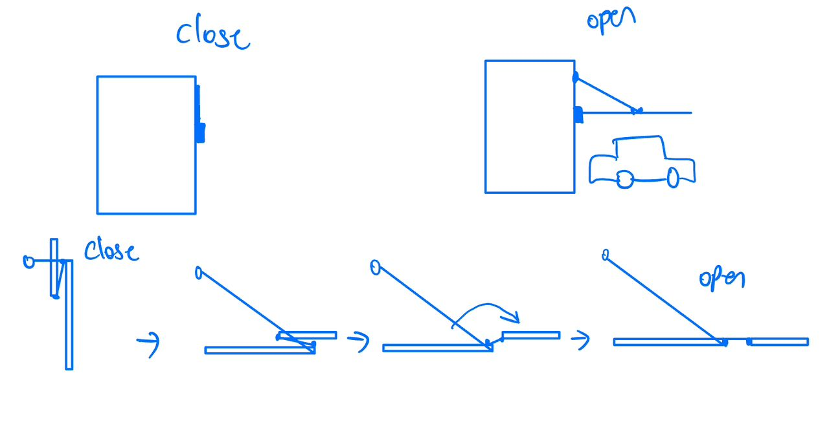

**FIFTH DRAFT**

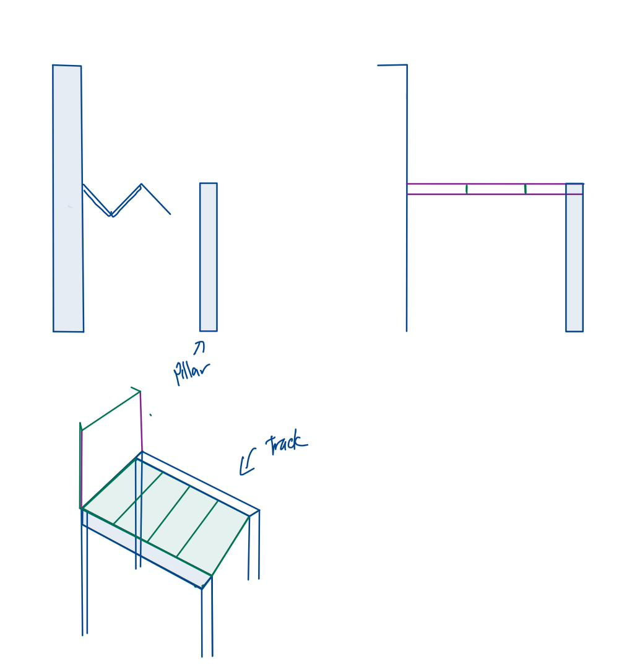

**FINAL DRAFT**



The reason that we choose this as our final draft is because it fulfills all of our requirements for our idea of smart canopy. It consists of a Humidity sensor, Light sensor, temperature sensor, 3 sensors that helps to indicate the environment situation. With the help of WiFi, it can access the weather forecast. GPS tracker in phone helps to locate the user’s location.

This design has a difference that compared to others design is this design helps us to solve the problem of stagnant water. For instance, after raining the rain water will flow down as we close our smart canopy.

**2.1.3 Interview**

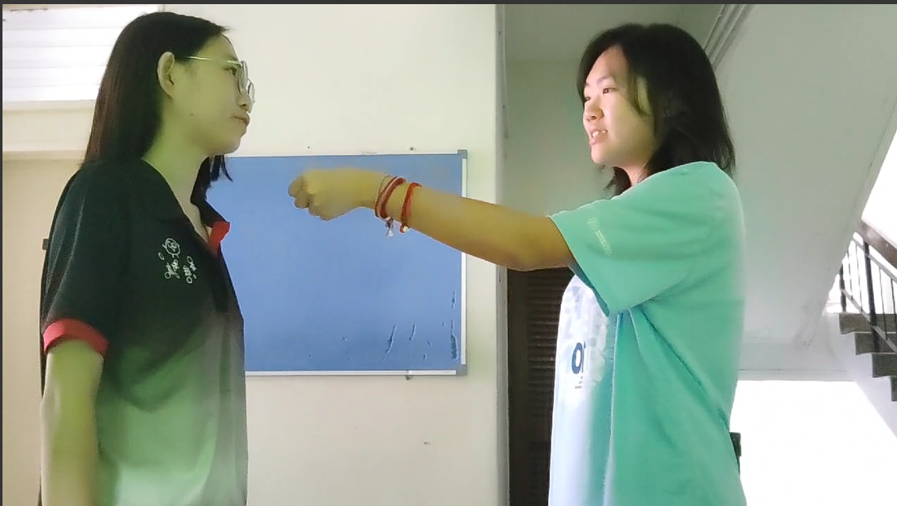

Q: During what occasion will you usually use your car porch area?

A**:** I usually use my carpoach area to do gathering such as barbeque or washing my car.

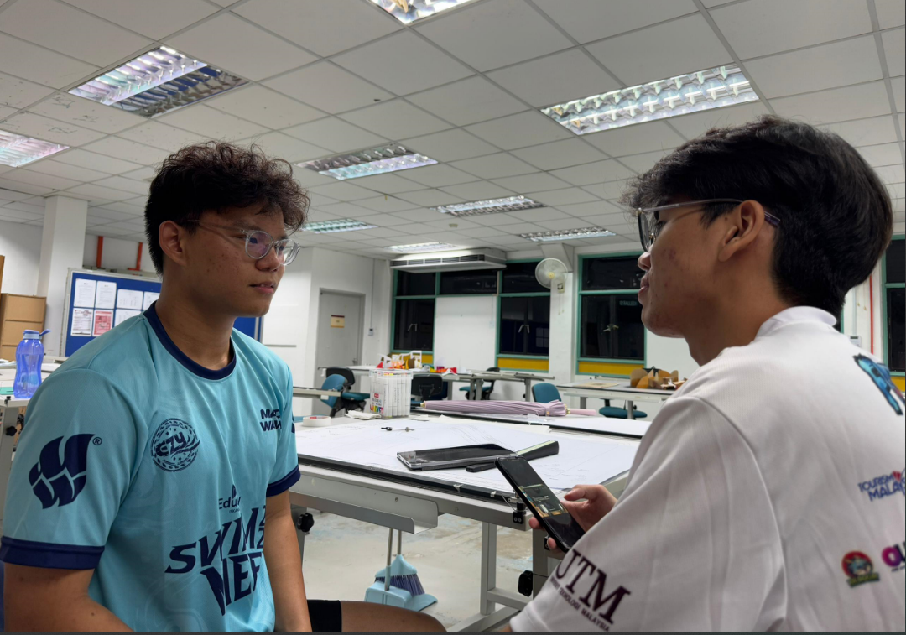

Q: Have you ever encounter situations like entering your house from the gate to door, you get wet because of rain

A: Yes, I am frustrated about that, especially when I am carrying something.

**2.1.4 Preparation of material**

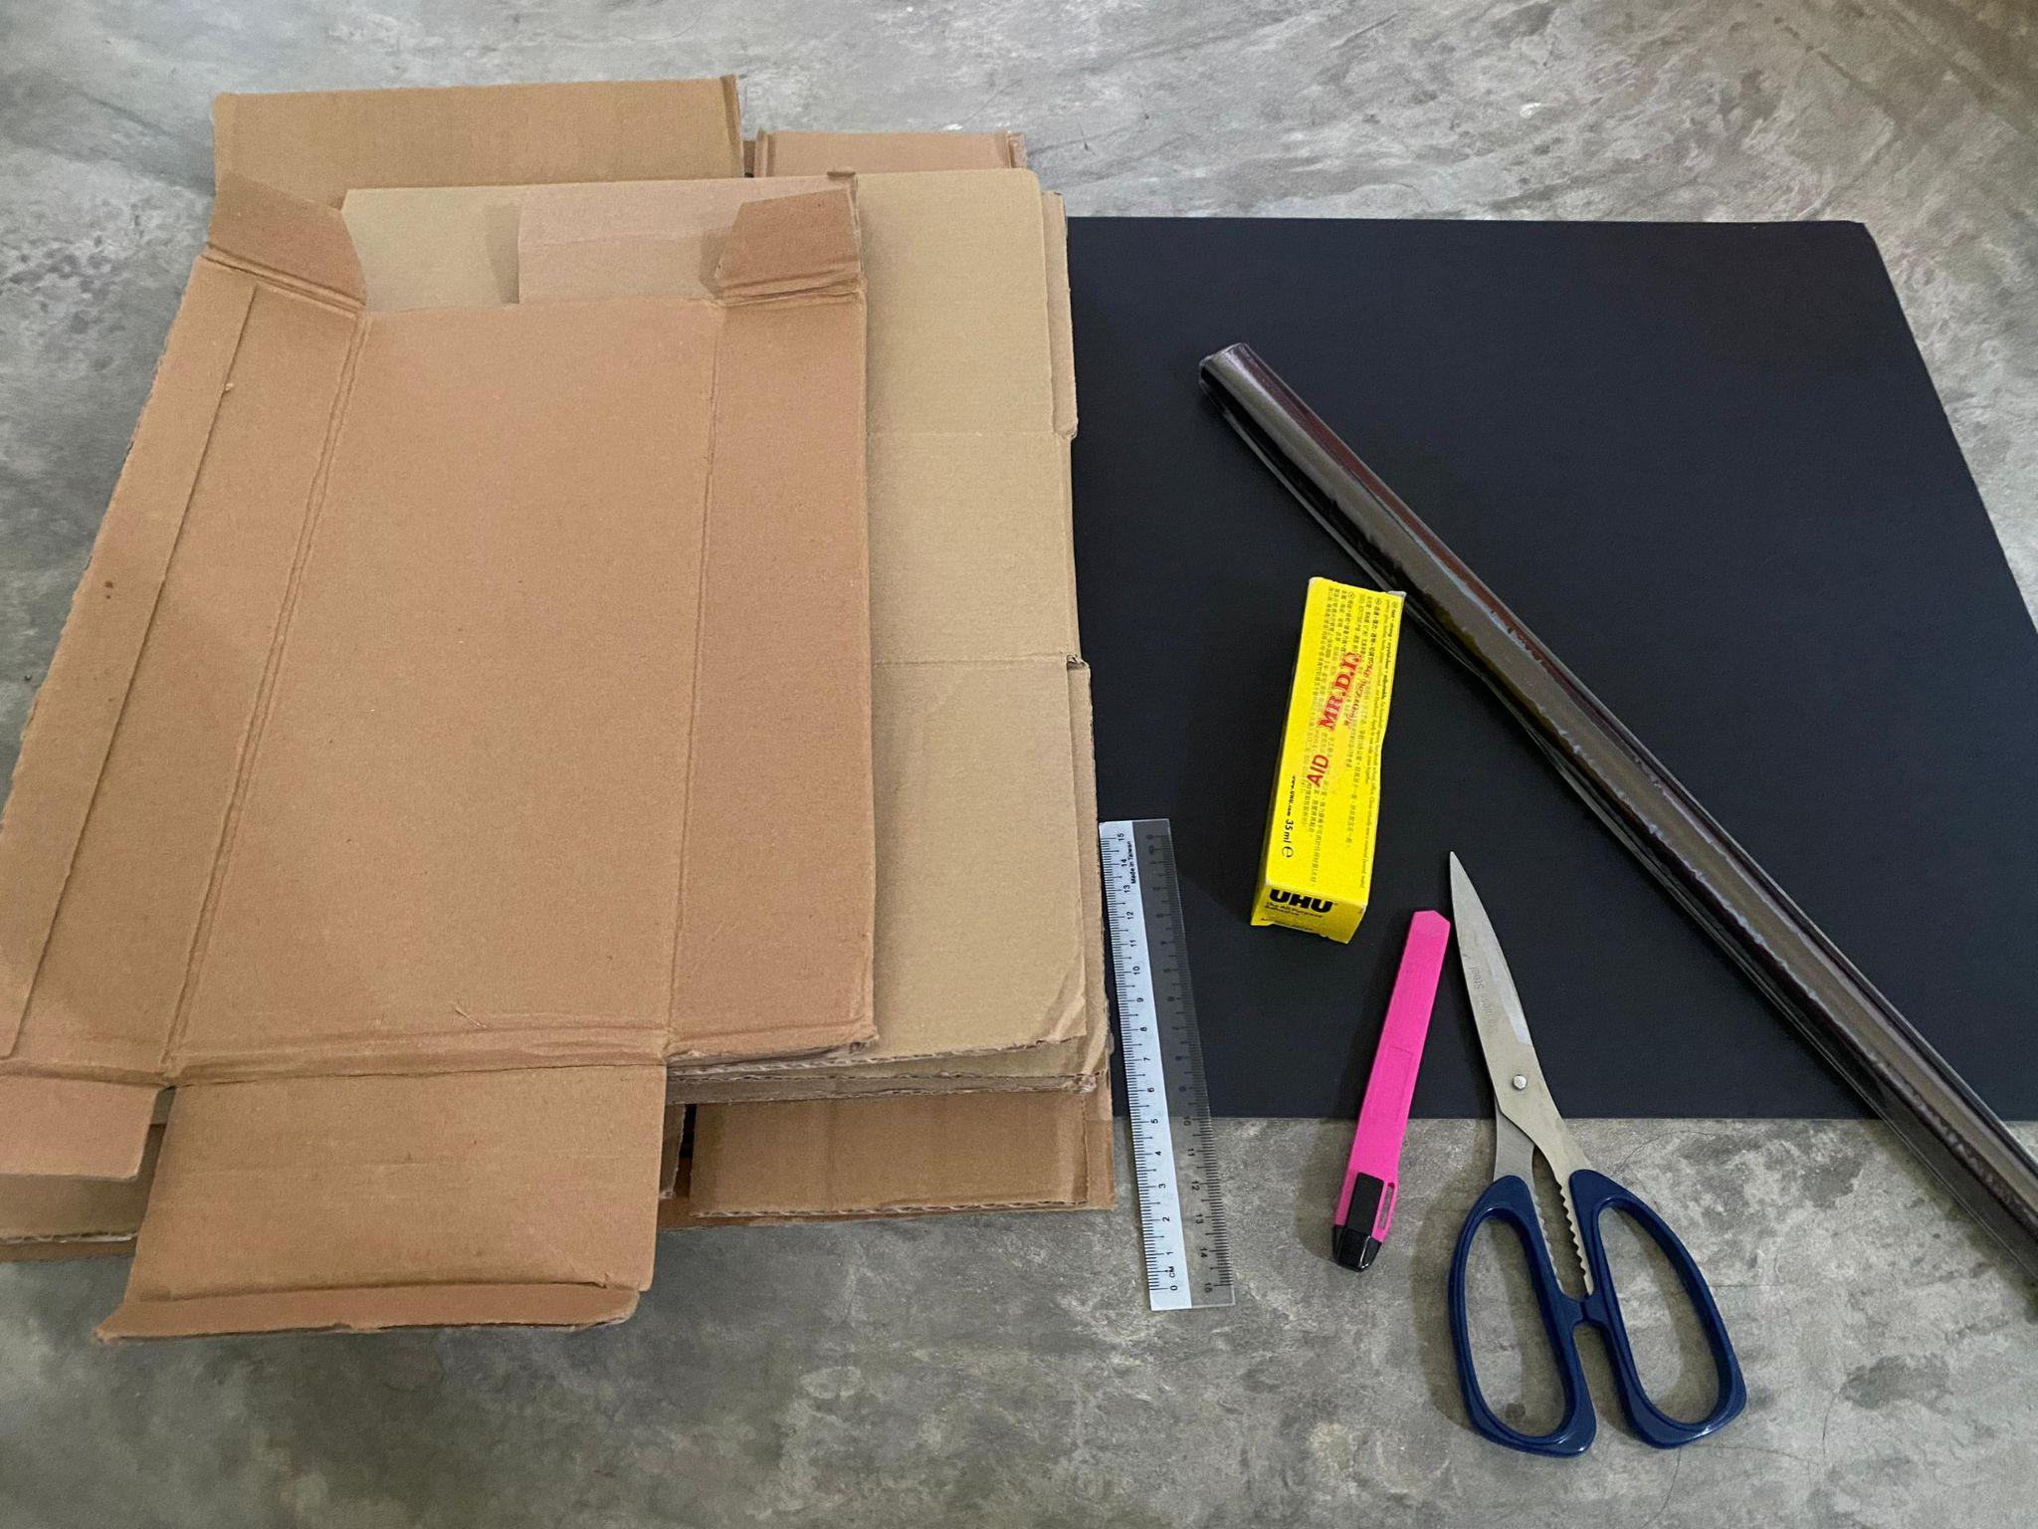

* Cardboard
* Craft paper
* Glue
* Scissors
* Cutting knife
* Ruler

**2.2 Working on product prototype**

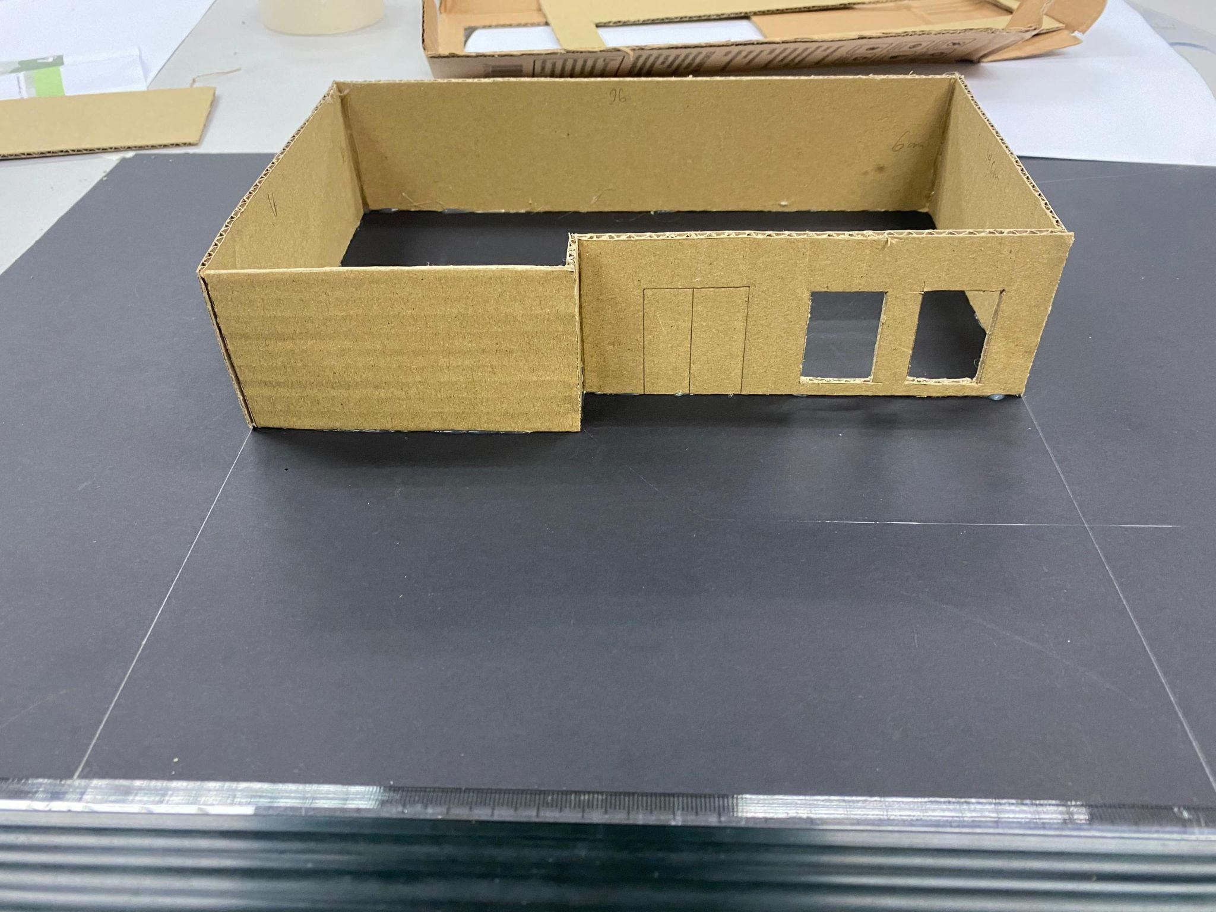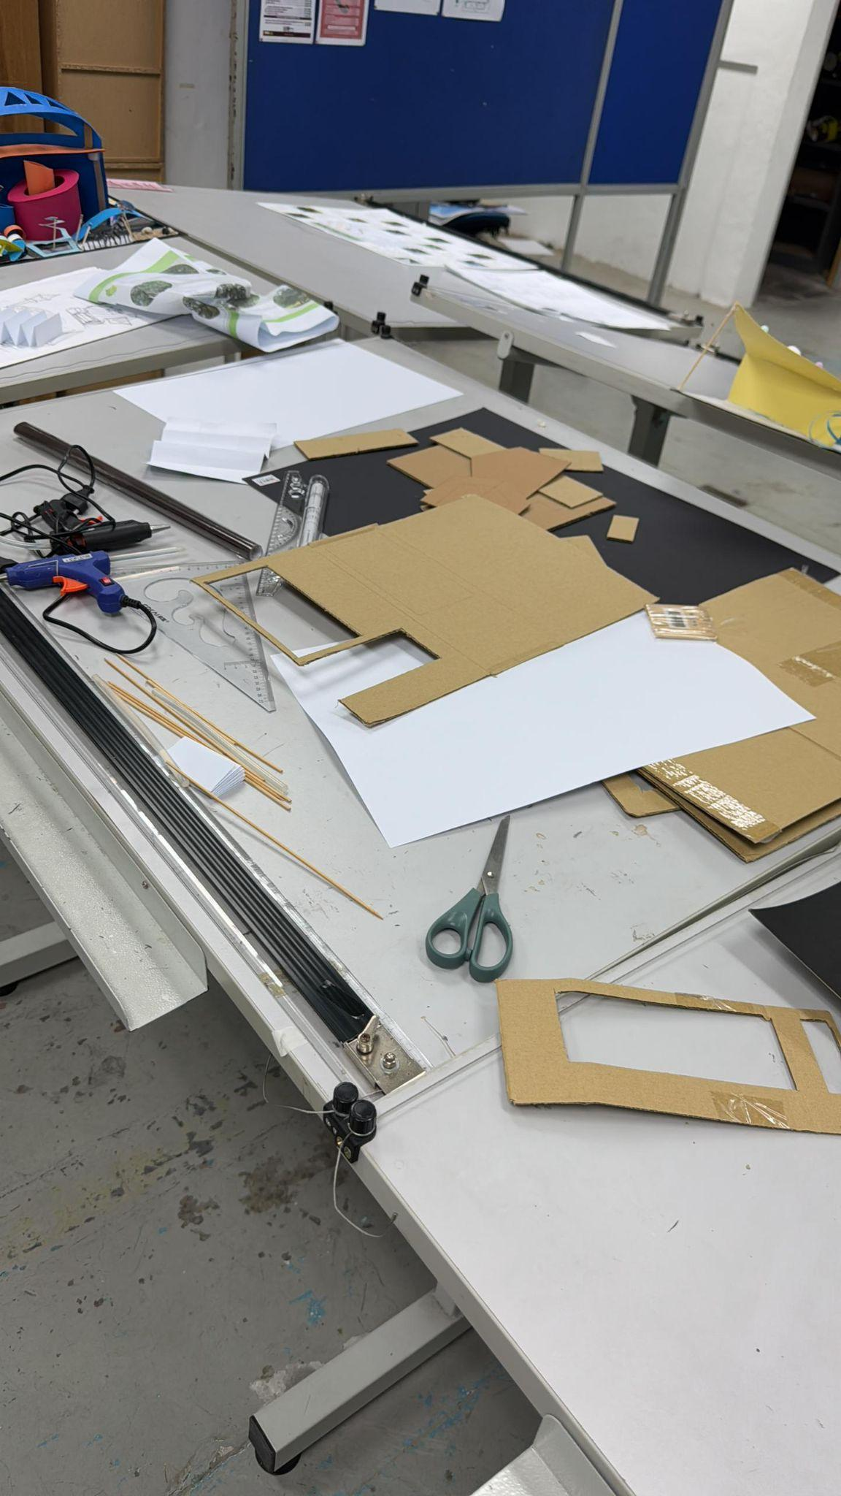

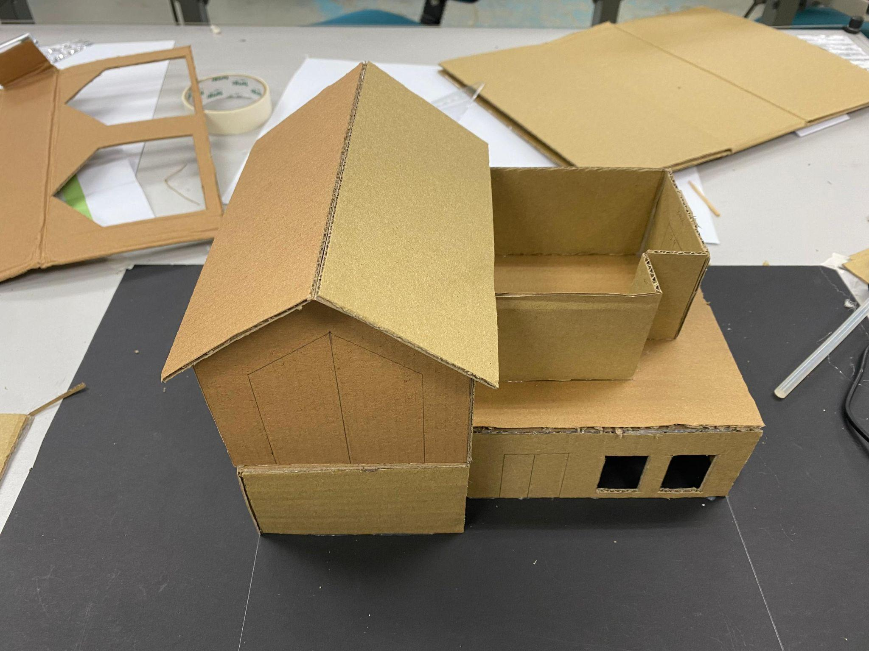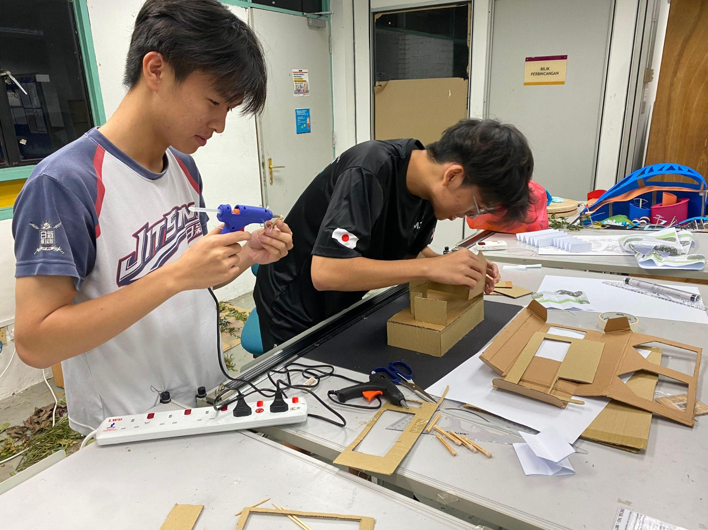

**3. Design Thinking Evidence**

**3.1 Empathy**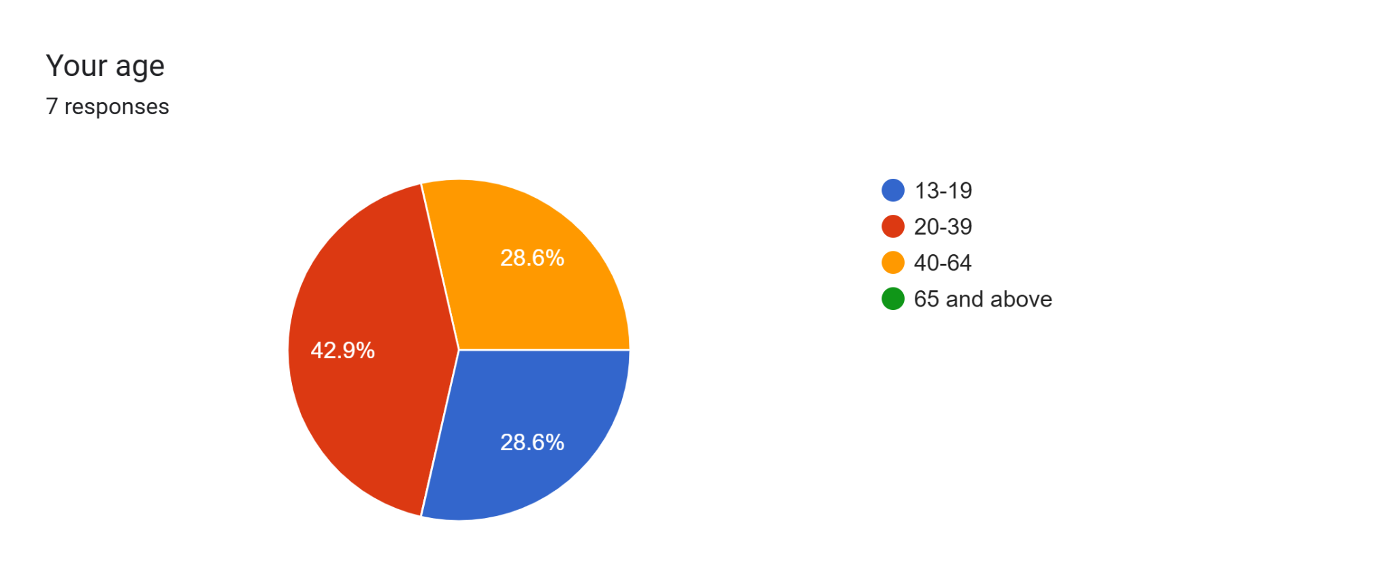

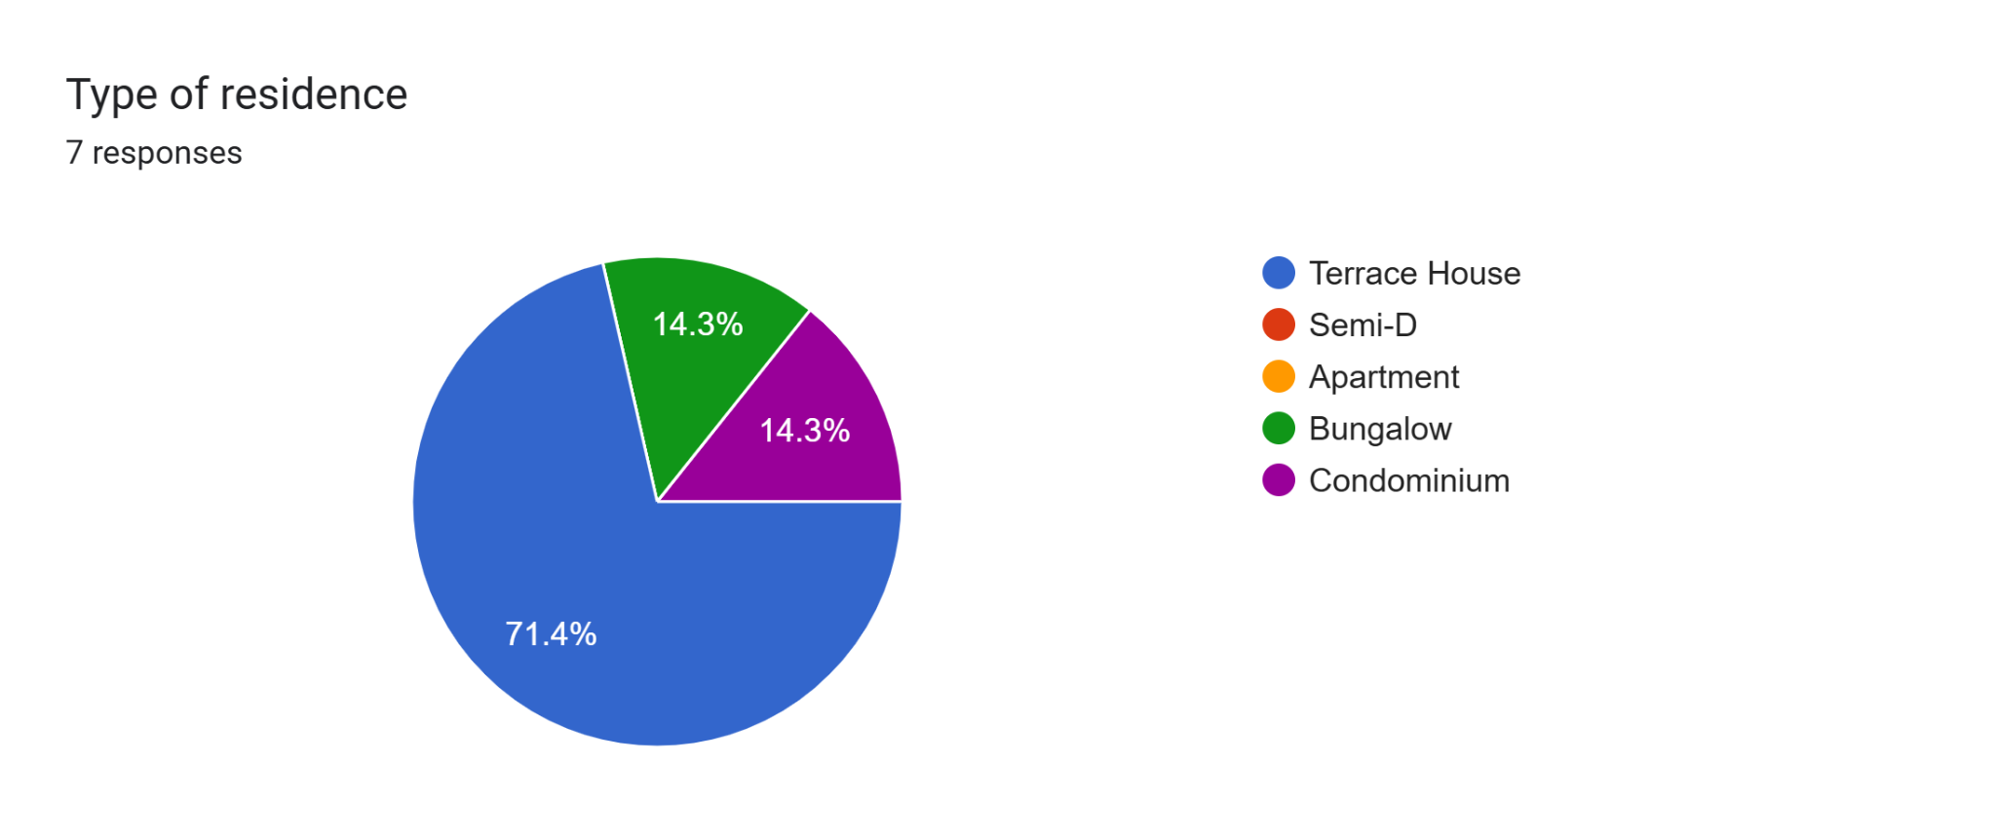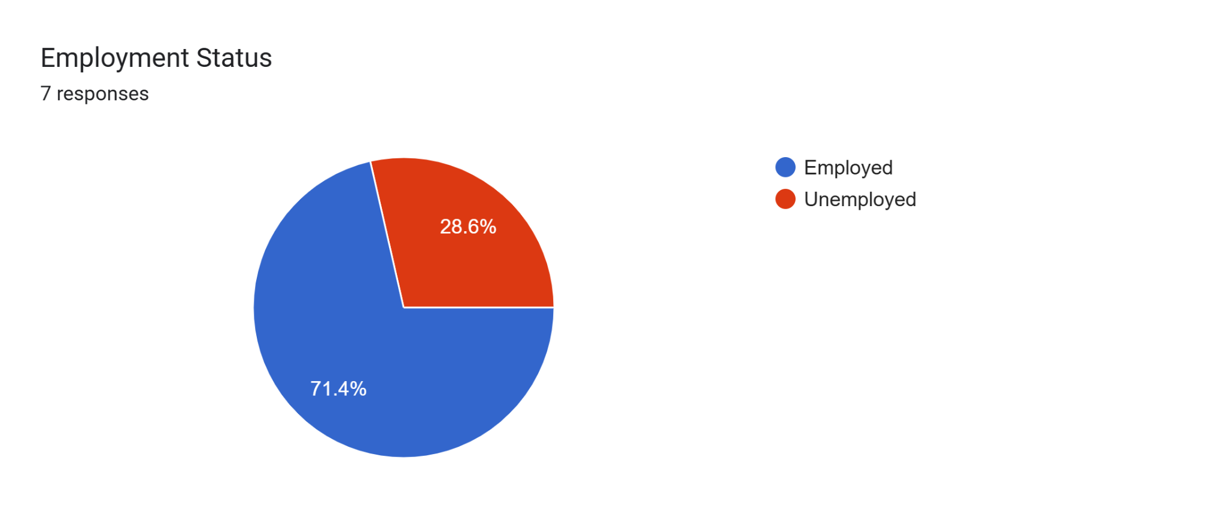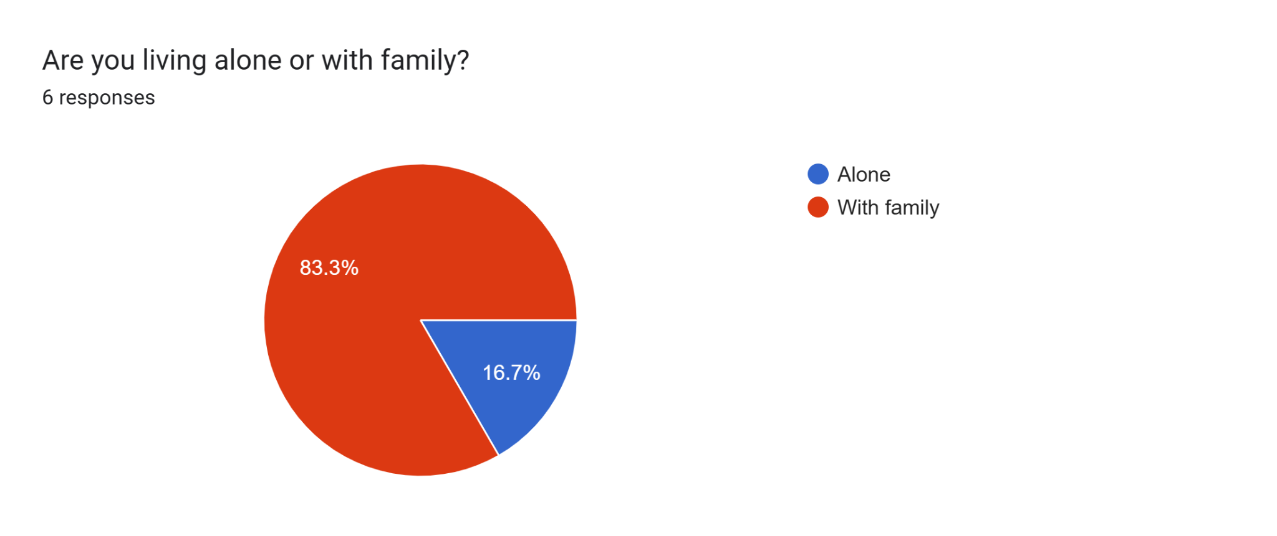

We did a little survey to identify our target customer. Our target customers basically are employed millennial generation living in Terrace House with their family.

**3.2 Define**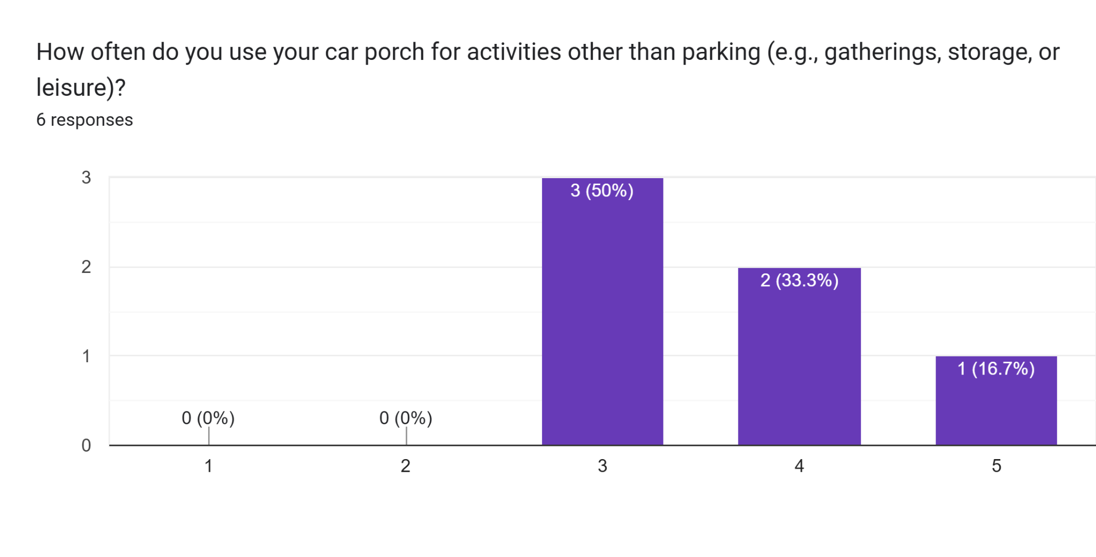

Based on our survey, our target customer quite often uses their car poach for various occasions.

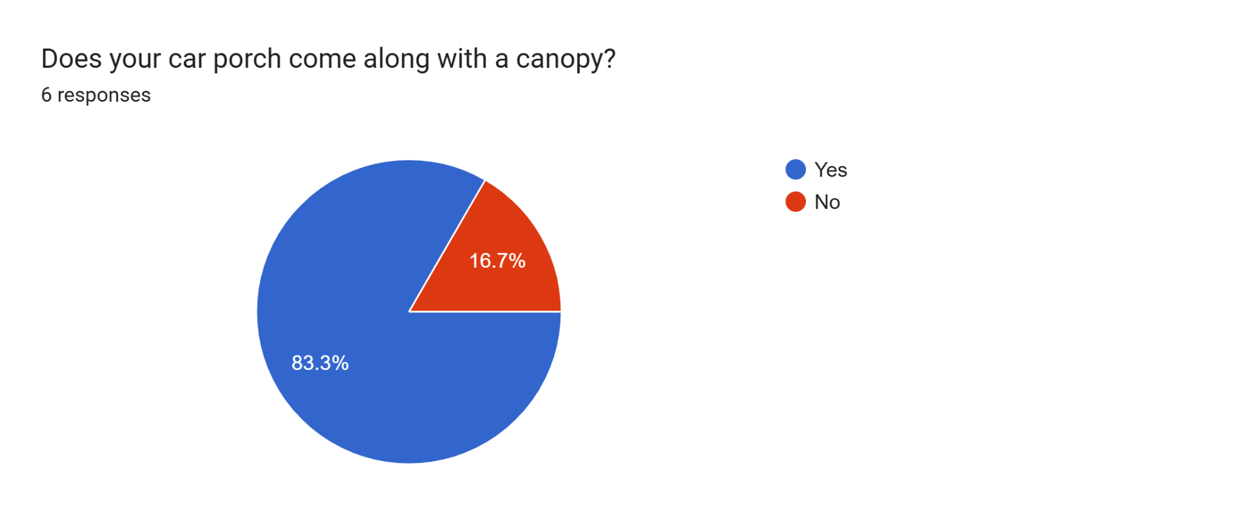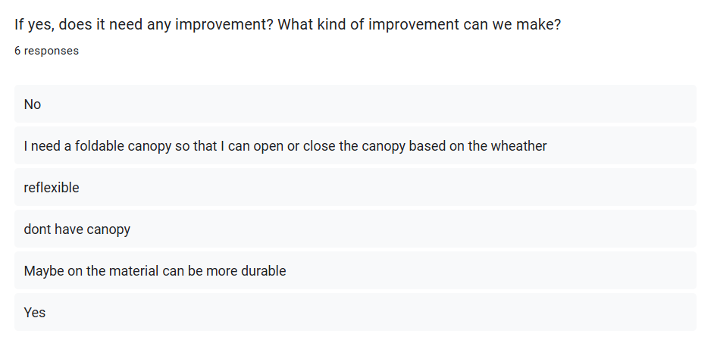

Most of our target customers’ car poaches come along with a canopy but they think that the canopy can have more features.

**3.3 Ideate**

We came out some innovative features and these are the satisfaction of our customers

The design is inspired by a roller window shader. We combine this element with the usual canopy.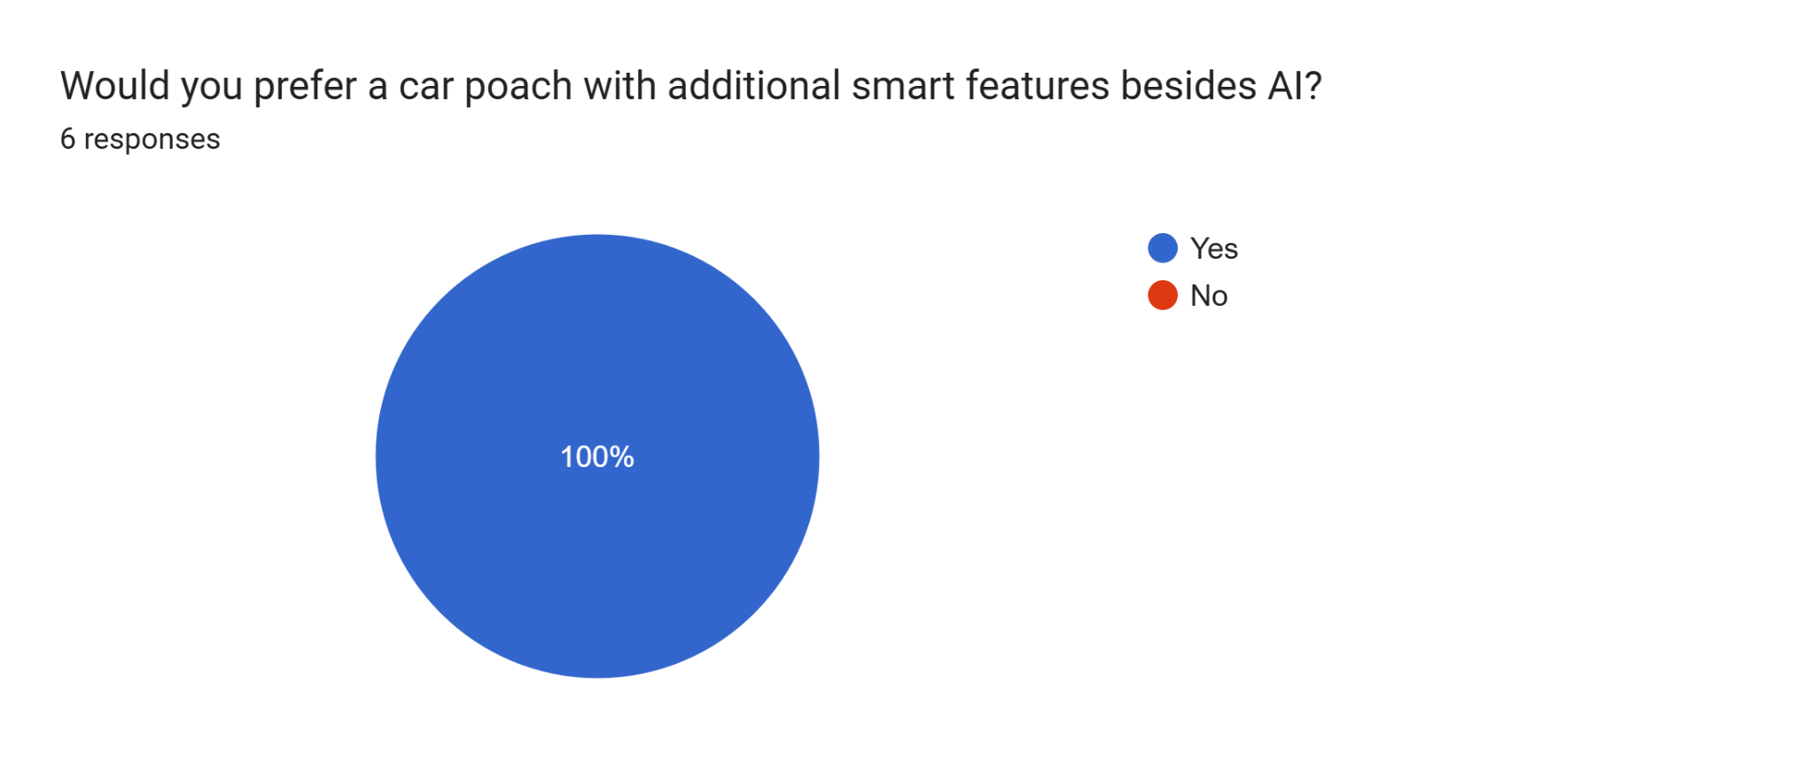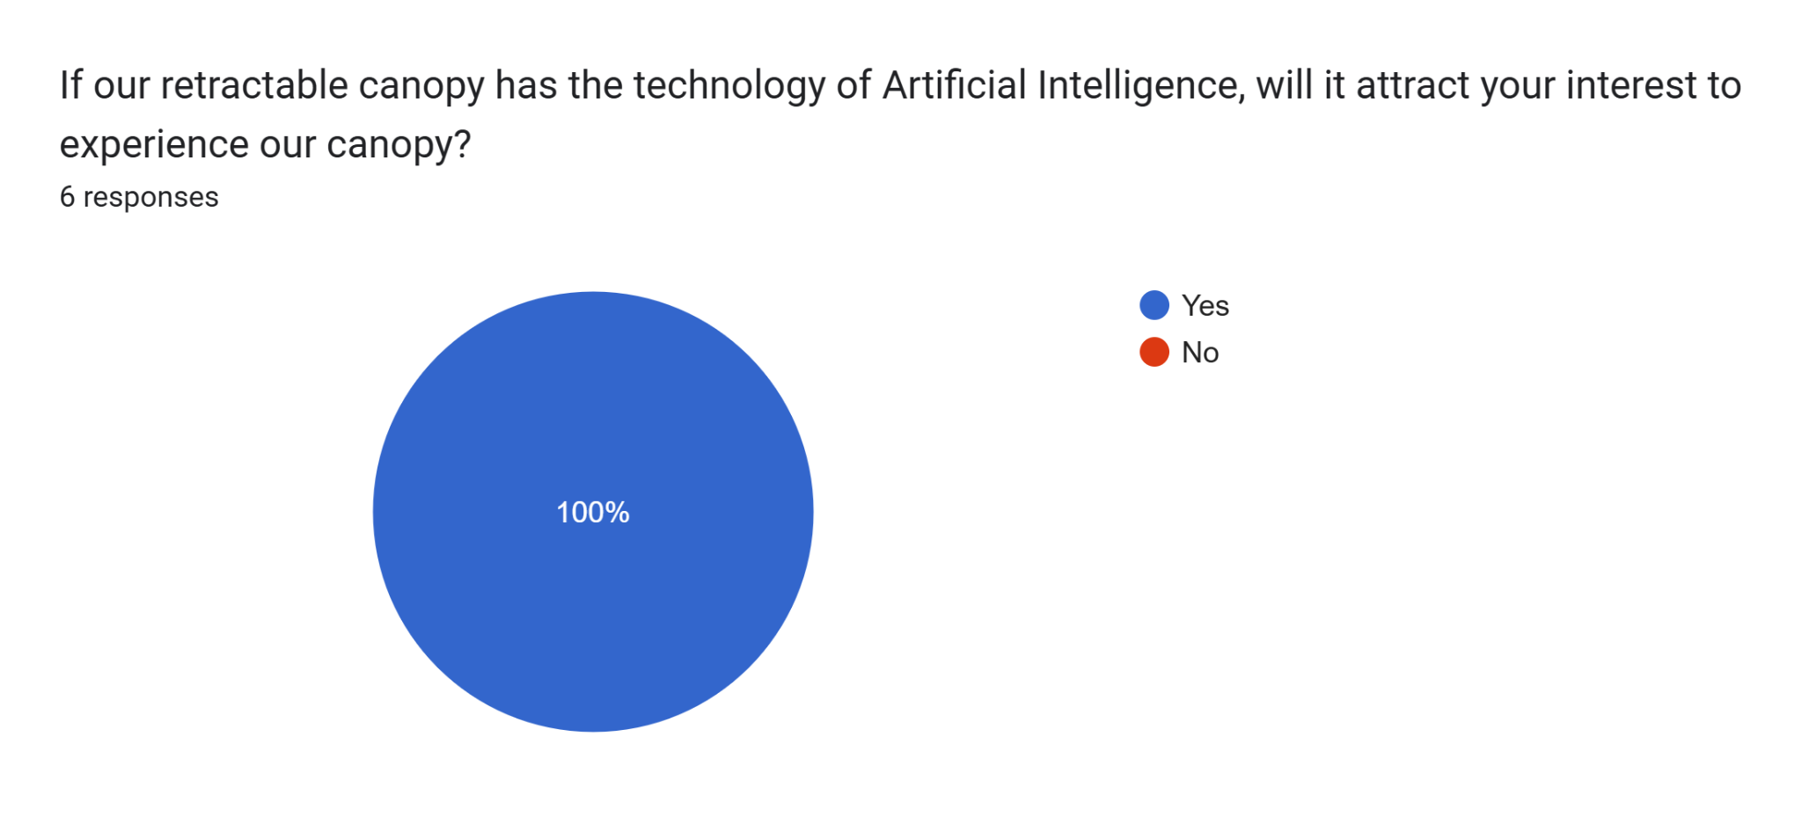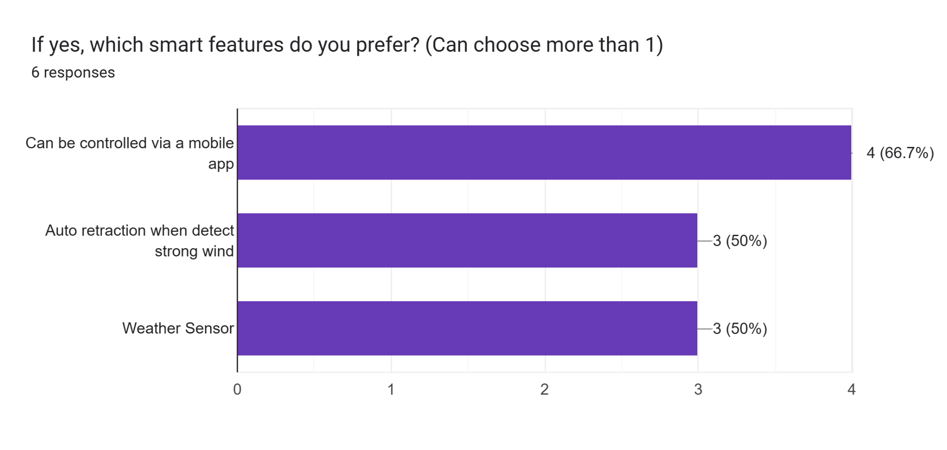

**3.4 Prototype**

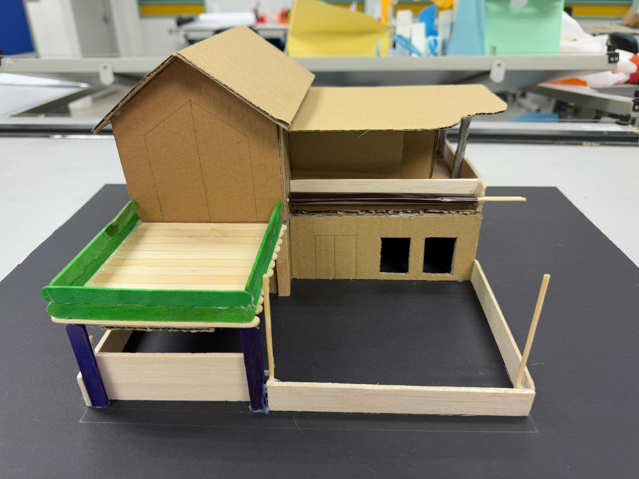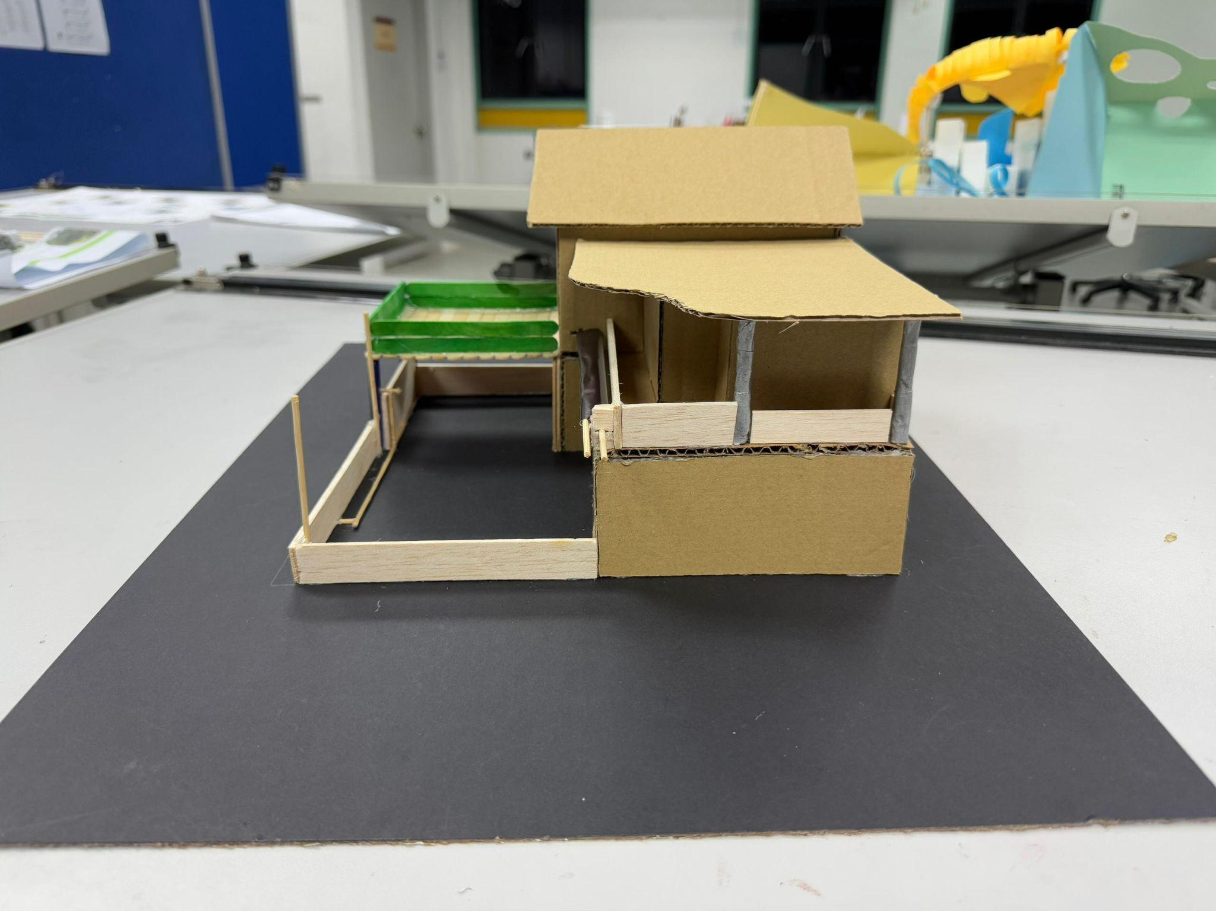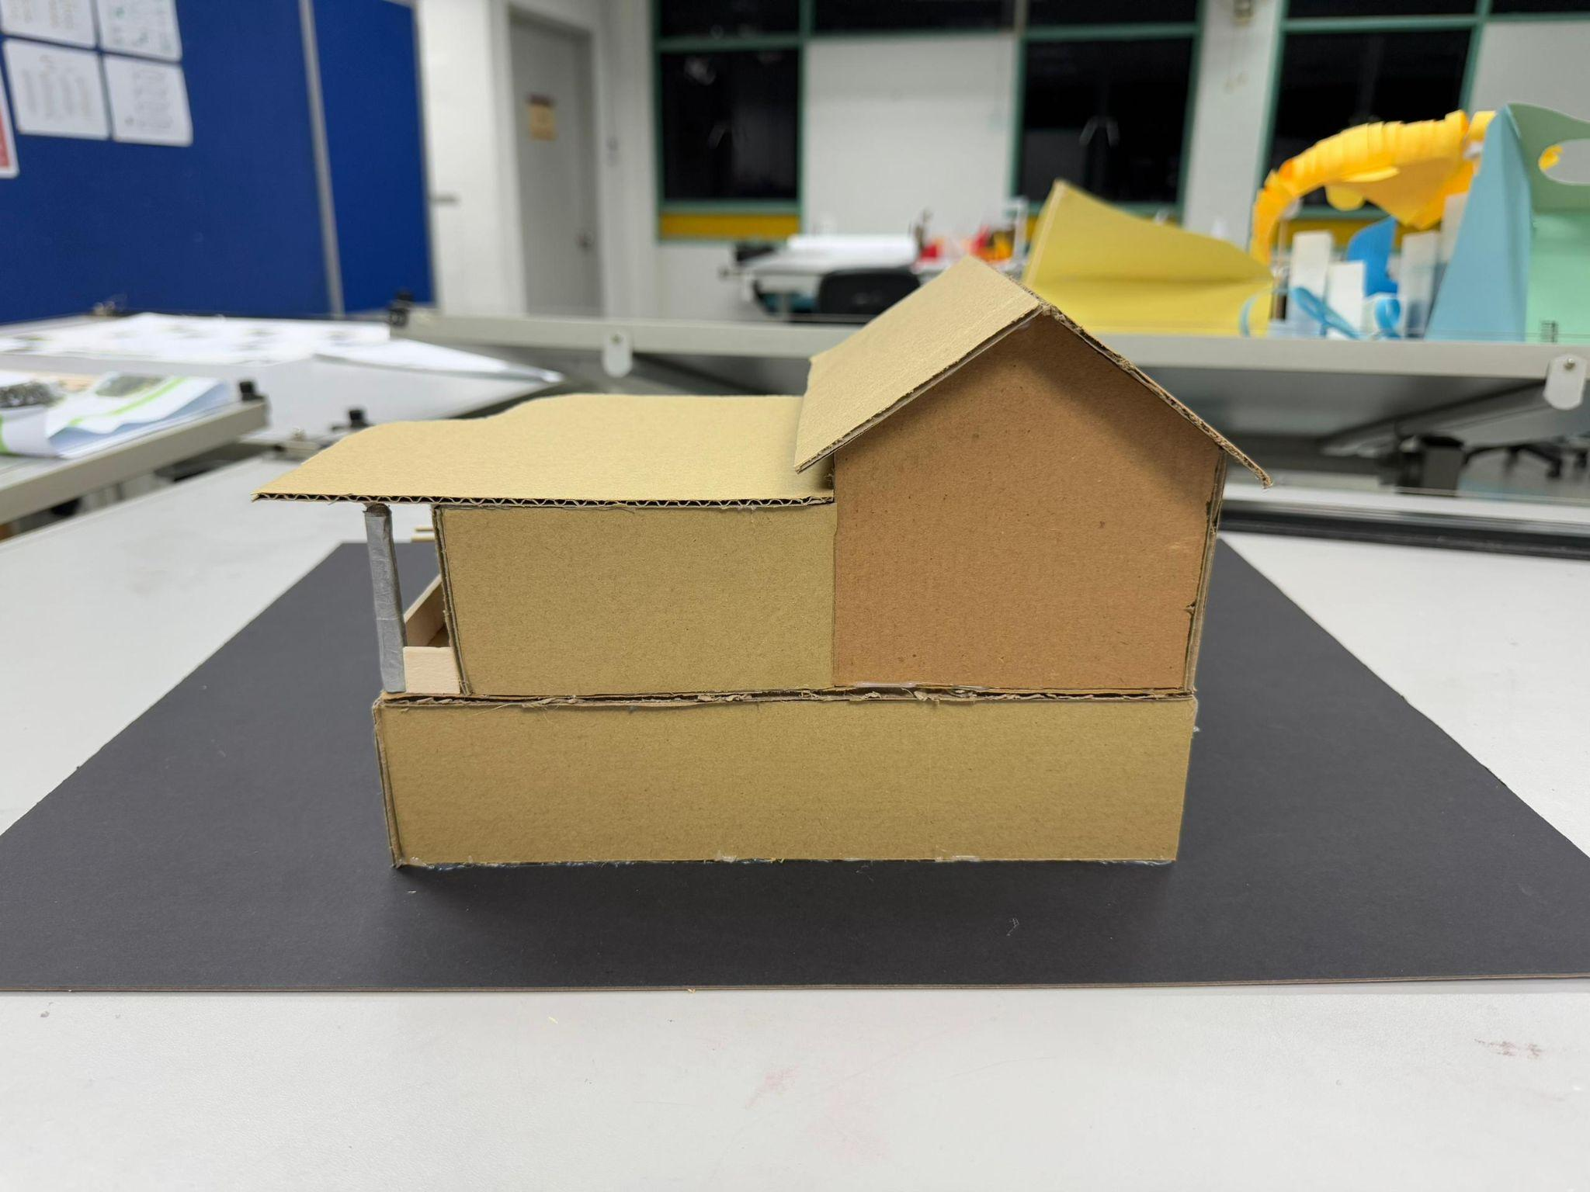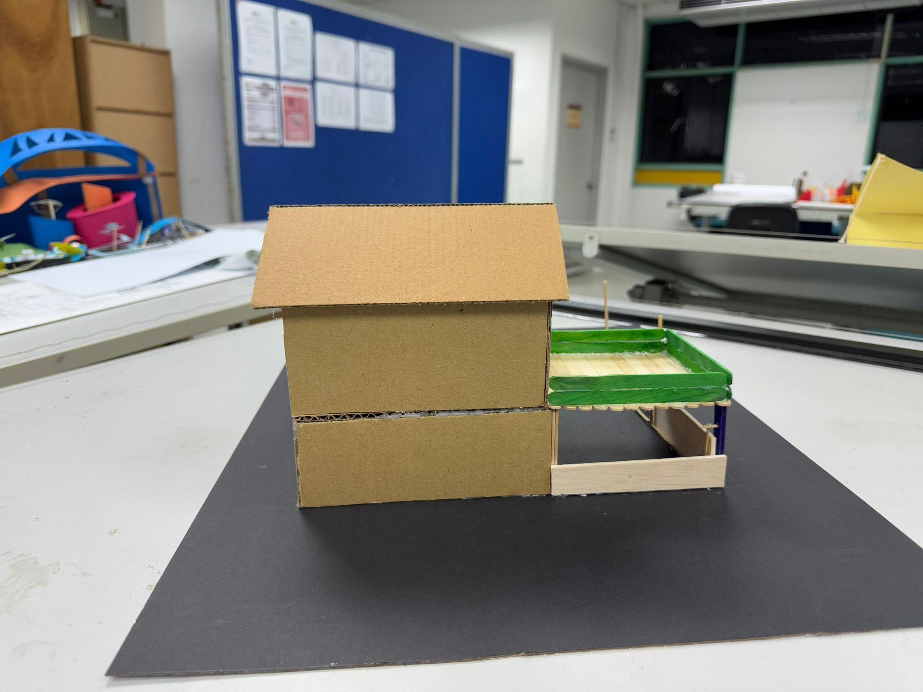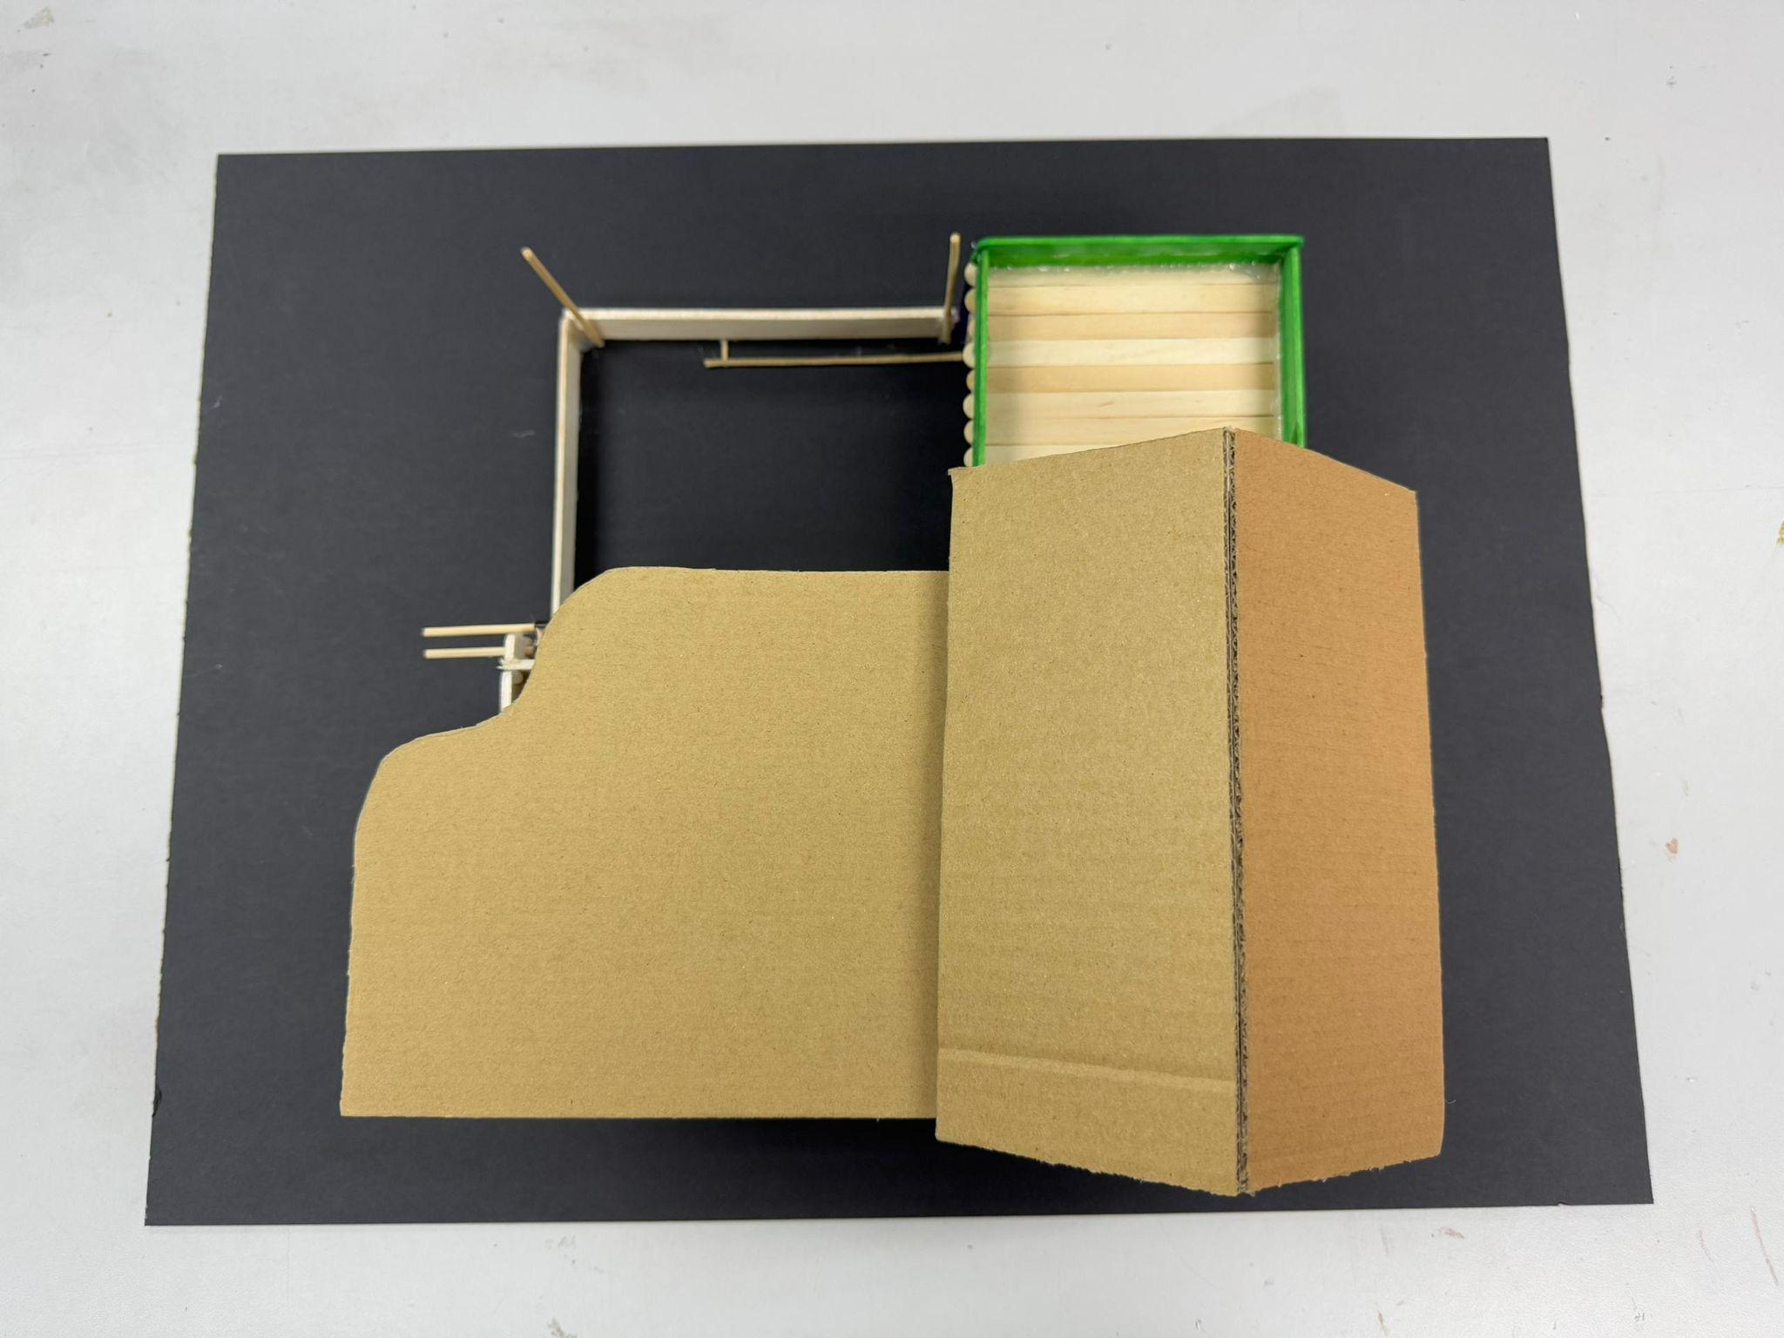

Our prototype model is a ratioed model and it is mostly made of cardboard. Users are able to interact with our main prototype which is the retractable canopy.

**3.5 Test**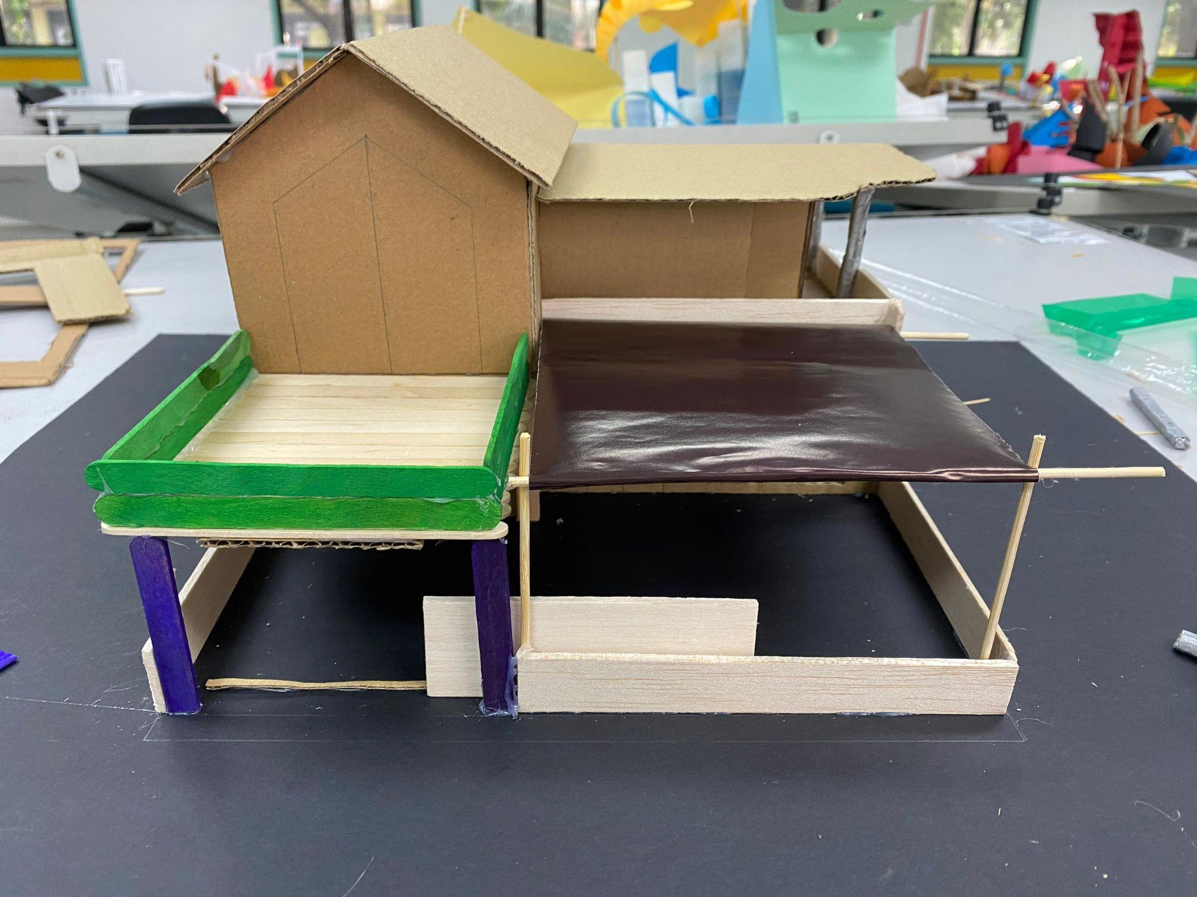

Our prototype is able to function. The canopy is retractable.

**4. Summary**

### This project highlights the process of designing and creating our innovative product which is the Smart Canopy. This idea was born from a common issue that faced by all of the car porch users that is getting wet in the rain or the problem that the porch cannot deal with the intense heat due to the limitations of the traditional canopies especially in Malaysia. Thus, with the help of IoT and Artificial Intelligence, we develop a more convenient and flexible solution for all the users.

Our project started with identifying the problem. We had done some surveys and we discovered that many users were frustrated with the fixed canopies, which are the traditional canopies. Our smart canopy includes sensors which have humidity, light and temperature sensors to monitor the weather. The smart canopy also includes an automation function for weather forecasts and a GPS tracker to detect when users are nearby. Manual Control is also an option to control the canopy for special occasions such as parties or washing cars.

Our prototype was made with some simple materials like cardboard , it is simple but successfully demonstrated how the canopy can be worked. From this project , we learned about how to turn ideas into reality while knowing the needs of users.

|  |  |
| --- | --- |
|  |  |
|  |  |

### 

**4.1 Reflection**



Wong Ya Jing  
My goal is to use my ability to build a better community. Through this course, I want to use my knowledge to let the community live more smartly. In the future, if I have the opportunity to realistic my design thinking project I will seek more assistance from bigger manufacturers.



Chia Thung Thung

My goal is to create a Smart Canopy that uses Big Data and Artificial Intelligence to improve environmental monitoring, save energy, and make life easier, supporting sustainable living and smart cities.



Edwin Oo Ming Hao

My goal is to leverage my skills to build a smarter, more sustainable community by creating a Smart Canopy that integrates Big Data and AI to enhance environmental monitoring, conserve energy, and support the vision of smart cities.

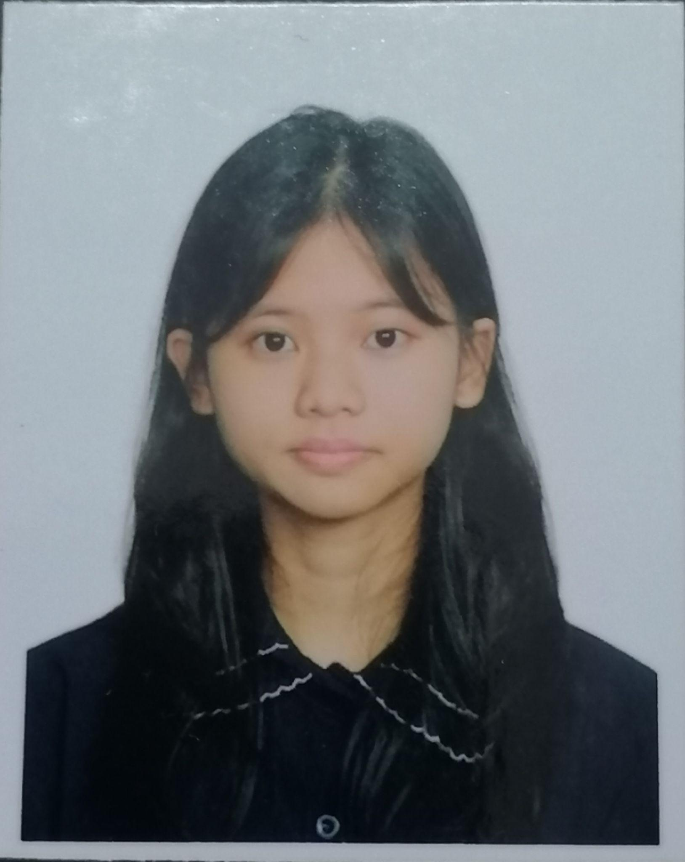

Abralyn Hoo Weng Yan

My goal is to use my skills that I have learned in this course to develop solutions that make our daily life more efficient and convenient. Through this project, I have the opportunity to combine my knowledge of IoT and Artificial Intelligence with practical problem solving to help people manage unpredictable weather better. I realized how technology helps people in their daily lives and improves it.



Yeoh Keng Wei

My goal is to create a better environment of communication between technologies and humans. With the help of AI in the project can improve the user interaction with our project of Smart Canopy. This project also help me to think from the user’s perspective and to create it easy to use.

**4.2 Role of each team member**



Wong Ya Jing( Team Leader)

* Coordinates task for each team member
* Monitor the progress
* Planning and decision making



Chia Thung Thung

* Video Editor
* Discuss and giving suggestion to have a better decision making
* Coordinates the group’s efforts



Edwin Oo Ming Hao

* Suggest draft of smart canopy
* Prototype Creator
* Create prototype of the canopy



Abralyn Hoo Weng Yan

* Finalize the draft of the prototype smart canopy
* Preparation of prototype material
* Contribute ideation process
* Writing the report summary

Yeoh Keng Wei

* Prototype creator
* Draft and create prototype of smart canopy